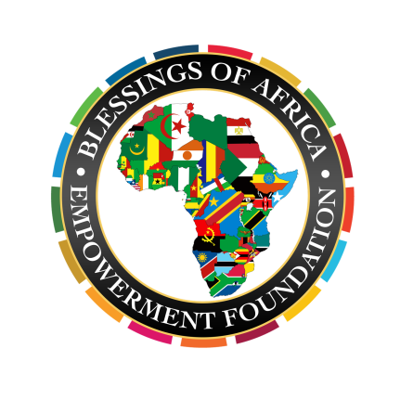
Blessings of Africa
Empowerment Foundation

“Blessing Lives, Dignifying the Needy”

Acts 20:35 “….I have been a constant example of how you can help those in need by working hard. You should remember the words of the Lord Jesus: ‘It is more blessed to give than to receive.’” NLT

It takes a Community to Dignify the Need! Join us as a Blessings of Africa HOST

Please contact Dr. Queen Blessing at blessingsofafrica@gmail.com for mailing address to submit completed donation forms

Event Host Sign In Form

Name: _________________________________________
Email: _________________________________________
Address: _________________________________________
City: _________________________________________
State: _________________________________________
Zip: _________________________________________
I would like to make a contribution to Blessings of Africa in the amount of:
_ $150 _ $75 _ $50 _ $10 _ $_______

_ I have enclosed a check.
(Please make check payable to Blessings of Africa)

_ I would like to pay via credit card:
(Choose one) AMEX Visa MasterCard

_ I would like to make monthly/quarterly/yearly recurring payments via credit card! (Circle One)

Name on Card: _________________________________________

Card Number: _________________________________________

Expiration Date: _______/_______Vin Number (required): ________

Name: _______________________________________

Organization: _______________________________________

Address (required): ______________________________________________________________________________

__________________________________________

Phone (required): ________________________________________

E-Mail (required): ________________________________________

_ I would like to be added to your mailing list.
_ I would like to attend/host an event.

Comments:
_________________________________________
_________________________________________

